Proposal submitted to DMOC responsible at National Department of Health – 20/3/2020

Social distancing includes urgently reducing contact with health facilities for those with chronic conditions
In South Africa, we have the highest number of people living with HIV (PLHIV) in the world at 7.7 million. We also know that approximately 3.5 million PLHIV are not virally suppressed of which 2.9 million are not on antiretroviral treatment (ART) and 700,000 do not know their HIV status.
There is so far no reported case of a COVID-19 infection among anyone living with HIV and so no evidence of an increased risk of infection or increased severity of COVID-19 among PLHIV. However, this could change rapidly as COVID-19 transmission increases in high HIV prevalence communities. We know from clinical data that the mortality risk from COVID-19 increases with older age and co-morbidities including cardiovascular or chronic respiratory disease, diabetes and hypertension.
WHO advice on management of people living with HIV during COVID-19 outbreak
  - On 17 March 2020, the World Health Organization published questions and answers on COVID-19, HIV and antiretrovirals².
  - WHO warns that PLHIV not on ART or who do not have a suppressed viral load are likely to have a compromised immune system and may be more vulnerable to opportunistic infection and disease progression.
  - WHO reports that there were only a few SARS and MERS cases reported among PLHIV who experienced mild disease.
  - WHO advises that PLHIV not on ART start ART immediately. Interactions with health facilities be kept to a minimum and PLHIV have a minimum of 30 days of ART with them but preferably a supply of 3 to 6 months.
  - PLHIV are also advised, similarly to the general public, to diligently practice precautions of frequent hand washing (with soap and water or using alcohol-based hand rub), good cough hygiene, avoid touching their face and social distancing (at least one metre apart).
This proposed set of interventions would augment the existing National Adherence Guidelines for HIV, TB and NCDs by supporting both patients with chronic diseases and the healthcare system for the duration of the COVID-19 outbreak. A minimum and enhanced set of interventions are outlined with operational details provided for specific chronic care patient populations.
At a time where we do not know the clinical outcomes of PLHIV co-infected with COVID-19, and in the context of a resource constrained public health system and millions of PLHIV not on treatment or virally suppressed, we need to take every precaution possible to avoid COVID-19 co-infection.
Proposed National Department of Health (NDoH) minimum interventions
Primary intervention: Provide a minimum of 3-month treatment refills to all chronic care and TB patients, including those starting treatment, until the end of the COVID-19 outbreak.
Operational details for specific populations:
A. Clinically stable chronic care patients already in Repeat Prescription Collection strategy (RPC) models
            - For patients collecting Patient Medicine Parcels (PMPs) previously scripted:
  - All PMPs distributed by RPCs models (facility pick-up points (old spaced fast-lane appointment (SFLA)/internal pick-up points), adherence clubs or external pick-up points (old Central Chronic Medicine Dispensing and Distribution (CCMDD)) to supply 3 months of treatment to support patients not coming to the facility/community venue again during outbreak.
  - All facility RPCs models (facility pick-up points and facility adherence clubs) – focus on ensuring the shortest possible time for a patient to collect their PMP:
    - Patients are not required to attend registry, collect folder, take vital signs or see a clinician.
    - A lay health care workers (HCW) should distribute PMPs from a table outside of facility building (e.g. in car park or community venue close to clinic) – patients should not enter facility building.
    - Patients should be encouraged to wash their hands before joining the queue.
    - Patients queueing to receive PMPs should be advised to stand 1 metre apart.
    - Patients should not be brought together for a group discussion but be seen individually at the table for distribution.

- For patients requiring rescripting
  - These patients need to be seen a clinician briefly. Patients should not be made to queue inside the facility but queue outside 1 metre apart after washing their hands and either be taken into facility to see clinician with their folder (retrieved by HCW) or the clinician can see patients briefly from table outside with a very brief check-up and rescripting.
  - Patients should be offered switch to TLD which has more secure stock supply over next 6-12 months. Education and explanation of TLD risks and benefits can be provided by lay HCW to patients as they wait in the queue outside.
  - Patients should be rescripted immediately (including for TLD if consent) with no requirement to come back for viral load review before rescript.
  - All RPCs patients should be provided with minimum of 3 months of treatment to ensure no return visit to the facility during outbreak and educated to only return if feeling unwell or experiencing side effects.

B. Clinically stable chronic care patients (including PLHIV on treatment) not in RPC models
            - For clinically stable chronic care patients not in RPCs but eligible
  - Use new stable eligibility criteria in Figure 1
  - Immediately offer and enrol in out of facility RPCs model – either community club or external pick-up point (community clubs will be operated as external pick up points run by lay HCW until end of outbreak (see each patient individually).
  - Follow same procedure as above in A.2. - rescripting for RPCs patients

Figure 1: Revised eligibility criteria to access RPCs
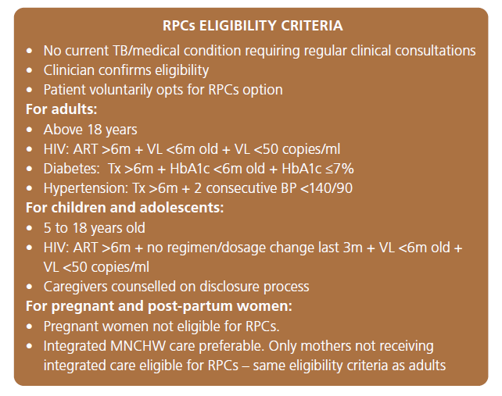
C. PLHIV not on ART
- Provide media communication and education to reach PLHIV not on ART with treatment literacy that starting ART will help strengthen their immune system which is likely to reduce risk of infection or severity of COVID-19 infection.
- Encourage patients to attend any available community service for ART initiation e.g. mobile or outreach site that is starting patients on ART.
- Ensure immediate ART initiation on diagnosis or presentation with an HIV positive diagnosis (same day) to ensure no unnecessary returns to the facility
- Educate patients on drug stock concerns, benefits and risks of TLD, assess for and offer TLD.
- Script for 3 months supply immediately with no return to the facility unless unwell or experiencing side effects
D. TB patients
- Ensure that all patients being started on TB treatment, or already on TB treatment, are provided with a minimum 3-months treatment supply.
- Eliminate queues inside health facilities (similar to chronic care patients) by setting up exterior queues (outside of health facilities) and separate each patient by at least one metre ahead of being seen individually by TB nurses. Standard infection controls for TB patients must be strictly adhered too.

Proposed NDoH enhanced interventions
- For those already clinically stable on treatment, provide the full 6 months refill until the end of the COVID-19 outbreak.
Operational details for specific populations:
Same as above except that:
- Clinically stable chronic care patients be provided with a refill for the full 6 months prescription.

- For all chronic care and TB patients write a prescription for 6 months to provide flexibility with treatment refill collection should patients not be able to return to see clinicians at health facilities after 3 months.

UNAIDS, https://www.unaids.org/en/regionscountries/countries/southafrica, South Africa, Accessed 20 March 2020
World Health Organization, Q&A on COVID-19, HIV and antiretrovirals, https://www.who.int/news-room/q-a-detail/q-a-on-covid-19-hiv-and-antiretrovirals, Accessed 20 March 2020

